December 13, 2016 Tentative Agreement
Between BAAQMD Employees' Association and Air District
Regarding Transit Subsidy for Supervising Air Quality Specialists
Recently, the Air District has reorganized the duties of Supervising Quality Specialists (SAQS) in the Compliance & Enforcement Division. Among these changes, employees in this class now work from the Air District headquarters location, and are assigned to the field on a more limited basis.
As a result of this change, employees in this class no longer are assigned District vehicles to take home. The impact of this change may have created additional transit costs for some employees.
As a result, the Air District agrees to offer employees in this class the District's Transit Subsidy as provided in Section 11.13 of the MOU. And, for those employees who have demonstrated costs in excess of the subsidy, the District agrees to offer them an additional subsidy.
This additional subsidy shall be paid to:
- Three (3) SAQS in the Compliance & Enforcement Division. The initial additional monthly amount paid shall be as follows:
    - Gambardella $48.00
    - Giacometti $48.00
    - Nelson $64.00
Should the District transit subsidy increase or should transit costs (based on their commute needs as of June 1, 2016) increase for these three SAQS during the terms of this agreement, the District will reassess and modify the additional subsidy to an amount necessary to mitigate the employees' any out-of-pocket transit expenses.
- The increase in transit subsidy for SAQS's shall be retroactive to June 1, 2016, the week the Air District moved to 375 Beale Street.
- Such additional payments shall terminate either:
  - Upon renegotiation of the provisions of the MOU which govern transit subsidy, or
  - In the event that any of the employees named above are no longer employed as an SAQS in the Compliance & Enforcement Division, additional payments to that employee shall terminate.
- This agreement shall not be considered precedential.
Tentative Agreement
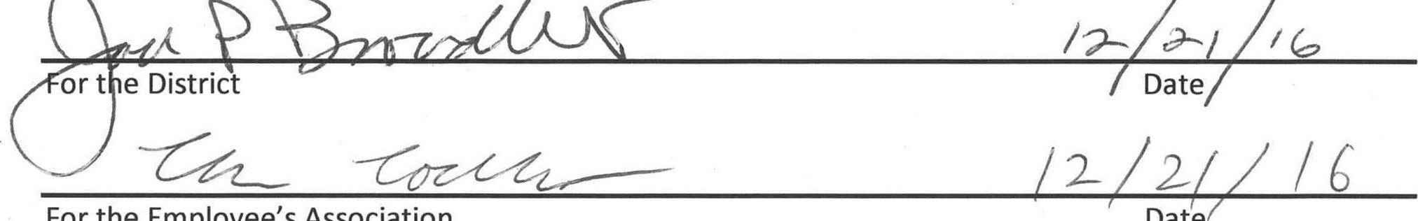
Date
For
the
Employee's
Association

